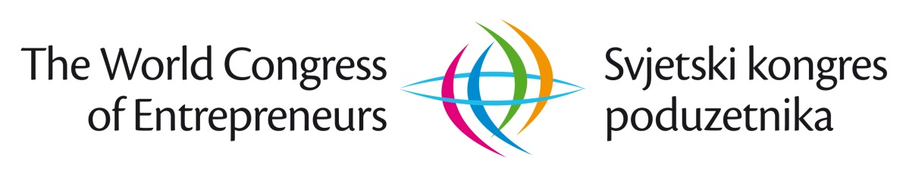
“ENTREPRENEURSHIP: PEOPLE. COOPERATION. DEVELOPMENT. SAFETY”

– Under high patronage of the Government of the Republic of Northern Macedonia –

WORLD CONGRESS OF ENTREPRENEURS
NORTHERN MACEDONIA 2019
_______________________________________________________
Basic information

(February 10 2019)

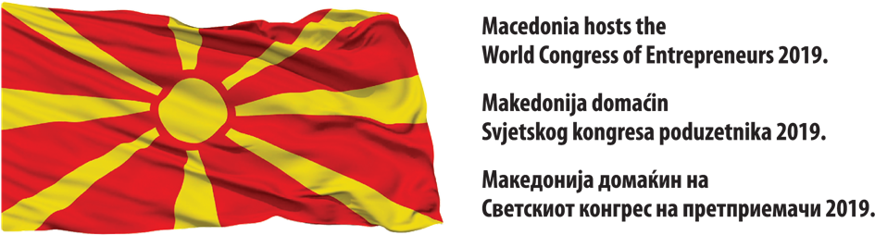
Based on the Commitment and Conclusion of the Government of the Republic of Northern Macedonia (RNM) from the session of November 27 2018
https://time.mk/c/b9a83b3bba/makedonija-zemja-domakin-na-vtoriot-svetski-kongres-na-pretpriemaci-vo-2019-godina.html and Decision of International Economic Forum PERSPECTIVES,

the second World Congress of Entrepreneurs will be held
in Northern Macedonia, from 16 to 19 October 2019.

Vision of the World Congress of Entrepreneurs is to become the high-quality business gathering that will continuously represent the platform for scientific and expert discussion by the representatives of business and academic community, state institutions and civil society organizations on the role and contribution of the entrepreneurship in global development.

Subject matter of the World Congress of Entrepreneurs is
“ENTREPRENEURSHIP: PEOPLE. COOPERATION. DEVELOPMENT. SAFETY.”

The fundamental leitmotif of organizing the World Congress of Entrepreneurs is the global challenges of contemporary society: wars, poverty, terrorism and planet endangerment, and advocacy for even, equal, sustainable and balanced development. World Congress of Entrepreneurs wishes, amongst other to, also define the role of entrepreneurs in contributing to resolving this global issue of the humanity. Thereby, World Congress of Entrepreneurs intention is not to change the world, but it has intention and need to contribute to changing the world - to better! World Congress of Entrepreneurs wishes to inspire the community for good deeds!

Main objective of the World Congress of Entrepreneurs is:
PROMOTION OF ENTREPRENURIAL SPIRIT, CULTURE, PURPOSE AND
IMPORTANCE OF ENTREPRENEURSHIP

Specific goals of the II WCE NORTHERN MACEDONIA 2019 are:

contributing to enhancement of regional cooperation with special reference on empowerment of commercial and economic connections;
promoting of investment potentials for bringing foreign investments but also encouragement of local investors from Northern Macedonia;
contributing to realization of Decision of Government of the RNM on Strategic priorities of the Government for year 2019 (No. 84/2018 of 9 May 2018) focusing on priorities 1 and 5 whose aim is to improve entrepreneurship, economy and education;
contributing to empowerment of cooperation between companies, universities, institutes and labor market;
contributing to enhancement of entrepreneurial ecosystem in Northern Macedonia.

Operational goals are: participation of 800 participants from 20 countries, consisting of: entrepreneurs, capital owners, top managers and managers of successful companies; prominent scientists-researches and experts in economy, entrepreneurship, marketing, finances and other subject fields; representatives of government and non-government sector as well as Prime ministers from countries participating in WCE 2019. Participation of European Commissioners responsible for economic sectors and representatives of significant global associations, is also expected: United Nations, World Bank, International Monetary Fund, European Bank for Reconstruction and Development...

Main sponsors of World Congress of Entrepreneurs, besides the Government of RNM and other major government, scientific and business institutions from Northern Macedonia, are: Government and Ministries of Economy and national associations and scientific institutions from the countries participating at WCE 2019. European Commission sponsorship and sponsorship of other relevant global associations is also expected.

Special initiatives that will be realized within the II WCE in Northern Macedonia, are integral part of the program and overall activities of WCE 2019. Following is highlighted:

- Discussion, improvement and promotion of Declaration “The Role of Entrepreneurship in Global Development”
- Announcement/Opening of the world`s second “Entrepreneurship Alley” in Skoplje
- Opening of the Youth and Future Entrepreneurs Center (YFEC) - for education of future leaders and promotion of positive entrepreneurial praxis “Perspectives” in Skoplje
- Nomination of the Entrepreneurship Ambassador
- Promotion of Worlds Entrepreneur`s Day (March 5)

Previous cooperation of the World Congress of Entrepreneurs and the International Economic Forum "PERSPECTIVED" in Northern Macedonia (NM) has been realized with numerous institutions and significant companies, among which are: The Government and Ministries of the RNM; City of Skoplje; Technological - industrial development zones “Skoplje 1 & 2; Chambers of Commerce NM; Association of Chambers of Commerce NM; Chamber of Commerce of North-West NM; Macedonian Academy of Science and Arts; University “St Ćiril and Metodij“ in Skoplje, Faculty of Economy “St Ćiril and Metodij“ Faculty of Skoplje, Institute for Economy, Faculty “St Ćiril and Metodij“ in Skoplje; V.I. TIKVEŠ jsc Kavadarci/Skoplje, ALKALOID jsc Skoplje, GRANIT jsc Skoplje, TRGOPRODUKT ltd Strumica, MAKEDONIJA EXPORT ltd Skoplje, VIPRO ltd Gevgelija, FAKOM jsc Skoplje...
And from 2019, within the Project for Promotion of Entrepreneurship “Creators for Centuries”, with: MAKPETROL jsc Skoplje; ELKOLEKT ltd Skoplje; HALKBANK jsc Skoplje; EVROSUROVINA PA ltd Bitola; PAKOMAK ltd Skoplje; EUROLINK OSIGURANJE jsc Skoplje; ADORA INŽENJERING ltd Skoplje; KIRO DANDARO jsc Bitola; A.B. NOVOSELSKI ltd Strumica; KIT – GO ltd Štip; INT-TREJD ltd Kočani; JSC for building and managing the spaces of interest for the Republic – Skoplje; BIM jsc Sveti Nikole; CENTER FOR ENTREPRENEURSHIP AND EXECUTIVE DEVELOPMENT, Skoplje; International School NOVA, Skoplje; ACCENT ltd, Skoplje; IDEA Plus Comunications ltd Skoplje; JU – SM ltd Tetovo; DPTU REPTIL ltd Skoplje; AMIKA ltd Probištip; SEMOS EDUCATION ltd Skoplje; BE-DA Logistik ltd Skoplje; ADING jsc, Skoplje; KAM ltd, Skoplje and others.

World Congress of Entrepreneurs is led by scientific and expert program-organizational bodies that consists of 200 respected individuals from all the spheres of public life, and experts from the field of economy, entrepreneurship, marketing, finances and other areas:

- Science-expert Council (SEC)
- International Program Committee (IPC)
- Organizational Committee (OC)
- Executive Committee (IC)
- General Secretariat (GS)

World Congress of Entrepreneurs, as a quality and important business and scientific-expert congress, has a powerful role in promoting the importance of entrepreneurship for overall economic development and great communicational potential. Therefore, World Congress of Entrepreneurs invites all interested parties for cooperation: business associations; companies; public institutions; bodies and agencies; scientific-educational and research institutions, non-governmental organizations, media...

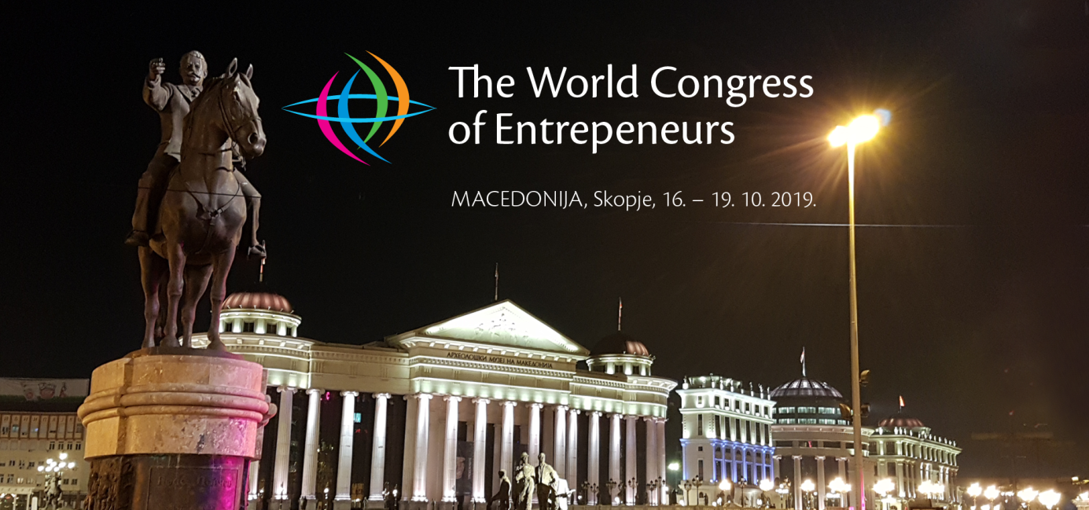

Ph.D. Sci Velimir Srića, Vinko M. Ćuro, Ph.D. Sci Siniša Zarić, Ph.D. Sci Bahrija Umihanić
President of Program Committee President of Steering Committee President of International Program Director
IEF “PERSPECTIVES“ Dubrovnik and IEF “PERSPECTIVES“ Dubrovnik Program Committee of WCE and World Congress of Entrepreneurs and Prof. at FE University of Zagreb and Secretary General WCE 2018 Prof at FE University of Belgrade Prof. at FE University of Tuzla
Zagreb, Croatia Dubrovnik, Croatia Belgrade, Serbia Tuzla, Bosnia and Herzegovina

I World Congress of Entrepreneurs I Northern Macedonia, 16 - 19 October 2019. I www.congress.hr I

